**THE TRUSTEE REGIME IN TURKEY**

**&**

**DENIAL OF RIGHT TO VOTE and RIGHT TO BE ELECTED**

**(31 MARCH- 20 NOVEMBER 2019)**

**Introduction**

*"The Municipal services under the trustees can be considered as a system. It is appropriate* ***to establish a system of which president will be the governor, who is the representative of the central government****, through a commission composed of the relevant ministries' representatives and universities. In this respect, the inspectorship office is of the opinion that t****he municipal council members should be election so as to ensure democratic participation and to form decision making processes, yet; the appointment of the mayor by the president to the provinces, particularly where our national security is at danger,*** *shall create a more suitable environment for the administration of such provinces.”*

These lines are from the Mardin Metropolitan Municipality report released in last September by the Civil Inspectors from the Ministry of Interior Affairs. The report, which was prepared by the Civil Inspectors to inspect the actions of corruption, irregularity and bribery of Mardin Metropolitan Municipality under the administration of trustee between November 2016 and March 2019, praises the trustee model and states that the appointment of the mayors to cities, where there will be "security weakness", by the President is "appropriate".[1]

Definitely, it is not a surprise that the inspectors, who went to Mardin to investigate violations during the trustee period, wrote a "report to applaud the trustee" rather than to pay attention to the hundreds of irregularities proven by reports, documents and witnesses. The report, which appreciates the then trustee, states that "it has been observed that the trustee (thanks to the strategy) established a good model through the combination of the central administration and local government" and notes that "there can be the Mardin Model in Trusteeship." Furthermore, it recommends that this trusteeship model should be applied everywhere.

Before the 31 March 2019 local elections, on 28 February 2019, we launched a comprehensive report to cover the trustee period between 2016 and 2019. The report, which documents its findings, demonstrates that the trusteeship regime was a terrible culturocide and sociocide project. We shared with the public that the Justice and Development Party's (AKP) narration about the trustees was composed of lies, deception and distortion. The hastily banning of the report and the order to confiscate it were the most evident indicators of the content of this report. It is certain that anything that is forbidden, denied and rejected in this country takes us one step closer to the truth.

The aim of this second trusteeship report, which covers the period between 31 March and 20 November 2019, is to show that 'the organized and planned violations of rights', which have been exercised under the name of trusteeship-which was disclosed in all respects-, is still in implemented by the current power coalition without any legal-rule-ethical values; it is based on arbitrary and almost colonial mentality and is pursued with a usurper understanding. Eventually, as stated in the concluding section of the 400-page report prepared by the Ministry of Interior's Civil Inspectors, it is to draw attention to the plan to eliminate local administrations. In this climate, which the ruling party labels everything and everyone as terrorism and terrorist respectively in line with its own interests, ignore the citizenship rights of the Kurds by using the concept of 'security'. The most effective antidote to these policies and practices is to resist this mentality, to defend universal rights and freedoms, and to build solidarity networks.

***

The first part of the report consists of a brief section to recall and remind what has happened. The elections on 31 March 2019 include a brief account of the trustees' period before the municipalities were taken back from them.

The next two chapters and sub-titles cover the chronological history of the events that occurred following the 31 March local elections that resulted in the reclaim of the municipalities by election.

This period has two stages. Until 19 August, there were attempts of attrition; after 19 August there are practices for which the relevant authorities do not even need to justify them. As of today, the latest available figures are shown in the graphs and tables.

The last section deals with the subject of law. It explains that the reasons that the State has shown with regard to the seizure of the will and theft for before the world's eyes and the legal provisions-which the State refers to- are not relevant and valid in this respect. There are grave violations not only with respect to law but also European Charter of Local Self-Government per se. We hope that the issue of trustees, which amount to be a tragic situation as clearly seen in the case of theUnion of Southeastern Anatolia Region Municipalities (GABB) and the individual stories of the co-mayors who have been detained, will be understood in a better way.

We share this report with you and underline that we will continue our struggle until we achieve freedoms, democracy and justice that is to say our fundamental rights; we have defended our model of local governments, which we have built through huge efforts, and cities, streets, villages, culture, all our political-moral societies; and we we will defend all of them till the end; we will not allow and accept the usurpation of the people's will; we are determined to protect and promote our differences, our beliefs and values that form our identity.

**Brief Background: What happened?**

As it is recalled, the Emergency Decree Law No. 674 issued under the State of Emergency, authorized the President to appoint a trustee to municipalities and the Governors to seize the properties of the municipalities and to dismiss employees in these municipalities.

The appointment of trustees, which began on 11 September 2016, has a notorious coup against local administration experiences, practices and achievements of the Kurds. In accordance with the Decree Law No. 674, trustees were appointed to the municipalities won by Democratic Regions Party (DBP) a member of HDP [translator's note: HDP is composed of different political parties]. In total, 95 trustees were appointed to the 3 metropolitan municipalities, 10 provincial municipalities, 63 districts municipalities and 22 municipalities in counties. The elected mayors were replaced with public officers. In parallel with the appointment of trustees, about 15,000 Kurdish workers and public officers almost 300 mukhtars were dismissed from their offices. The 93 co-mayors, hundreds of municipal council members and provincial council members were detained and sent to prisons. 15 of these co-mayors were sentenced by the courts.

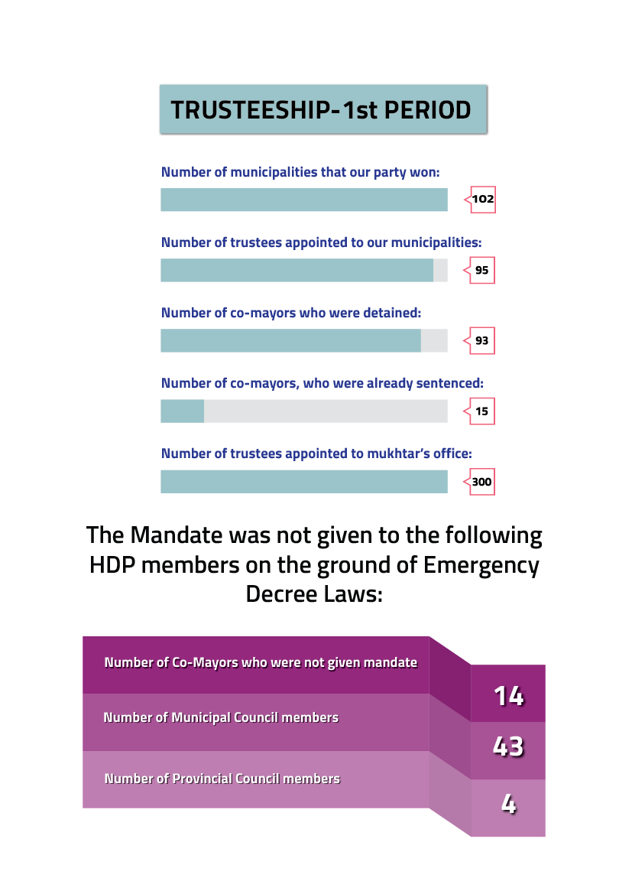

Assimilationist policies have been practiced in the period of trustees that can be summarized as stolen spaces, looted economy and values, distorted data and the usurpation of daily reality. Contrary to the Government’s discourse the appointments of trustees were not a necessary “measure” but a considerably well planned political and administrative action and are so substantial for democratic rights that it cannot be simplified.

Unlike the Government’s discourse, the trustees did not compete for service but sharing the unearned income, corruption and irregularity. They are not ordinary public officers but specifically selected officers. If we look the practices of trustees between 2016 and 2019, it will be clearly seen that the issue is entirely related to the approach to the Kurdish identity and values. The HDP report, which was released on 28 February 2019 and explains the details and practices of the trustees, shows that the HDP municipality understanding based the democratic-ecological-female libertarian local principles is targeted [by the government].[2]

For this reason, we codify the trustees' appointments as a continuation of the denial policy against the Kurds for hundreds of years, and we call this period the name ‘The Trustee Regime’. This regime is built on evil and seizure; based on memocide and culturocide; it is a misogynist and a regime that takes all kinds of unearned income, corruption and irregularities as an example.

There is a clear evidence about this issue; right after their appointments, 9 trustees were taken from their offices for corruption, the suspension of 55 of these trustees for having relations with the religious sect, and the Turkish Court of Accounts filed 58 criminal complaints against 58 of them.[3]

In this regard, many motions by the HDP to investigate these issues were rejected by the votes of AKP-MHP and numerous parliamentary motions were not answered by the relevant authorities in the Grand National Assembly of Turkey (TBMM).[4] On the other hand, the inspectors detected no single corruption or irregularity in the municipalities where they almost camped. Another important issue to be underlined that following the 31 March local elections these trustees were almost rewarded since they were appointed to the western part of the country and to higher positions.[5]

The most important distinguishing characteristic of this period, which we will call the first trustee period, is the approach to women's achievements. As soon as they took over the control of municipalities, they targeted first women and their institutions and processes that were socialized, organized and transformed by the women. The understanding of local administration based on democratic, ecological, female libertarian principles and women's achievements in political life were seen as a threat to monolithic power, and there was no tolerance to women's participation in political mechanisms. As a matter of fact, their first actions have been the elimination of the mechanisms and institutions established for the empowerment of women in local governments. The peculiar women's system, which had been built for twenty years, has been ignored and intervened in the memory of society to eradicate everything. The trustees revoked the whole order that enabled equal representation of women in local administrations, excluded women from the speech and decision-making processes; it deems its main task of deepening male-dominated state structure and deepening gender-based problems, and intensified black propaganda on the target of co-presidency system implemented by our party at the level of local governments.[6]

**31 March Local Elections and the Following Period**

The 31 March local elections were held in a very tense political atmosphere. On the one hand, there were hundreds of strikers in all prisons, on the other hand the economic crisis and the effects of war on all sides certainly created a challenging election atmosphere.

There was a great determination in the places, where the trustees had been appointed, and immense unequal conditions were prevalent in the elections; the people considered the elections not as an [ordinary] elections but "voting in favor or against the trustees" and went to the ballot box with this motivation. The Government used its all ideological apparatuses on the field, tried to break the will of the people through special war-oriented practices; thousands of people, were registered in places though they were not eligible voters in these places; ballot boxes were moved or merged;[7] made propaganda to spread hopelessness in other words it did try every way to break the hope of the people. Although it was the case also in the Western front, it was more more intense and systematic in the geography of Kurdistan. There were statements to threat people and candidates several weeks before the elections to declare trustees would be appointed if our candidates win the elections, there was an attempt to discourage people from voting.[8] Such statements and attritions attempts were made even a week before the elections.[9]

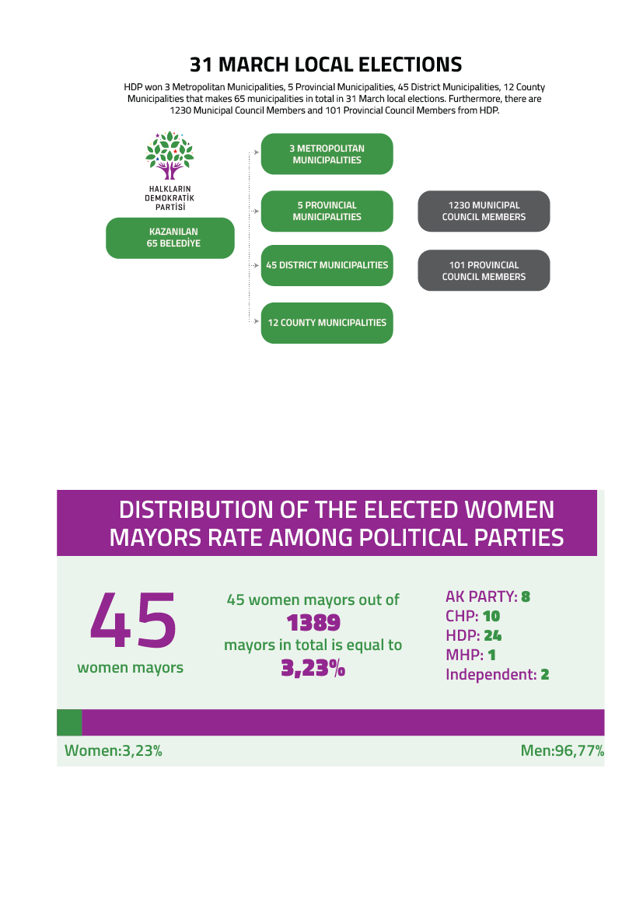

There was a high level of participation in 31 March local elections. Definitely, there was a special attention to the municipalities that the Government had appointed trustees. Despite all types of fraud, pressure, blockings, HDP won 3 Metropolitan Municipalities, 5 Provincial Municipalities, 45 District Municipalities, 12 County Municipalities that makes 65 municipalities in total in 31 March local elections. Furthermore, there are 1230 Municipal Council Members and 101 Provincial Council Members from HDP. Thousands of police officers and soldiers were deployed to certain districts in Şırnak[10] and Hakkâri.[11] As a result of this practice AKP won elections in some of these districts. Although we appealed against this practice yet failed to get any result.

The municipalities were taken back from the trustees about 30 later than they had been appointed; the calculation of the balance sheet of the financial loss that amounts to economic destroy of the municipalities immediately began. The resulting facts go beyond the limits of imagination. Hundreds of examples of luxury, waste and corruption were shared with the public. There was a wide range of consumption from private bathrooms[12], to horse farms; cups sets to different types of Turkish bagels that were brought from other cities are located thousands of kilometers away from the municipal locations[13], to super luxury special dinners[14] and expensive gifts.[15] Yet, it was only the tip of the iceberg. It is clear that the AKP has been following a roadmap to accept some minor expenditure so that it will cover these facts and to manipulate how and where the actual expenditures are transferred. It is certain that the plunder cannot be reduced to kadayıf, a special dessert in Turkey, and bathroom. The real and terrifying situation can be seen in the following chart.[16]

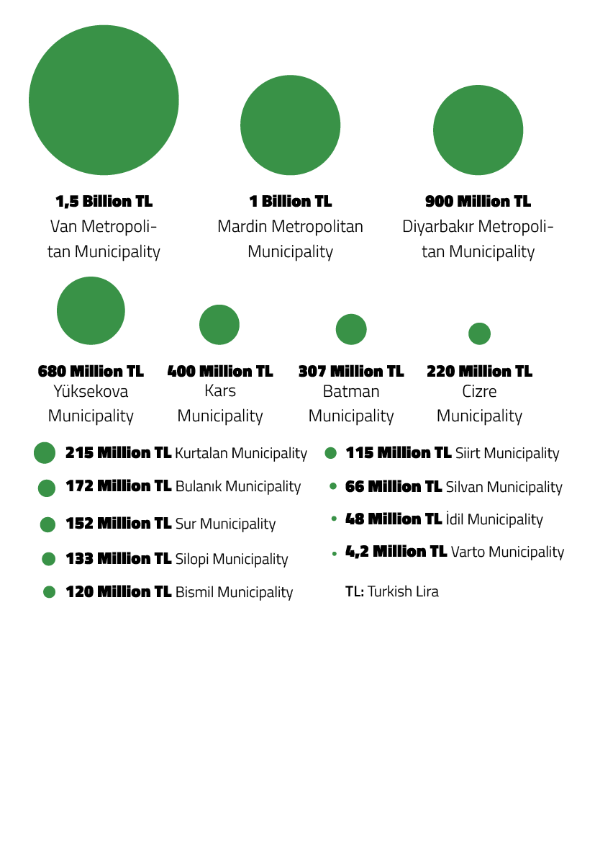

Although the trustees had a “zero debt” campaign, the amount of debt reached to 6 Billion Turkish Lira. It needs to be stated that it is the amount which we were able to calculate. It should not be forgotten that the real debt amount is least double to this calculated amount.

**Yüksekova Municipality Case**

According to this debt statements, Turkey's the most indebted municipality is Kurtalan now. The amount of debt in such small place is 215 million TL. The annual budget of the district of Hazro in Diyarbakır is less than the amount of debt; other districts are in a similar situation.

Yüksekova is the most obvious case punishment through the debt issue. The amount of debt in this district-which has a population of 36 thousand and 4 million monthly income- is 680 million TL.

The amount of loan only from the Bank of Provinces is 608 million TL. How can the Bank give such a loan to a small district? Secondly, where has the money been spent? The amount is enough to destroy and rebuild the district yet it is unknown where the money has been spent. It is stated that the astronomical loan from the Bank of Provinces was spent sewage with an incomplete drinking water line and treatment plant. However, there is still no sewerage system in Yüksekova and people are digging cesspools. Thus, no system has been built with this money. More importantly, the trustee clearly lied to Iller Bank. Because the municipality's own income is only 200.000 Turkish Lira per month from 9 thousand water subscriptions, while the Bank of Provinces was told that the district has a population of 500 thousand and the monthly water income of the municipality was 5 million Turkish Lira.[17]

Apart from the financial situation and the internal problems of the municipalities, one of the main issues was how the State would approach and what would be its relations with these municipalities in the new process. The AKP has worked hard and made propaganda to the whole world that the trustees were successful so that they would be re-elected. Therefore, the general perception was that the AKP would not accept the official results. Needless to state that no one had difficulty in predicting that the State would approach to the municipalities in a ‘vengeful' manner in the new process as well. Soon later, the response began to come. And it turns out that in fact, there was a will to maintain the practice of trusteeship in many ways. First of all, a new and peculiar situation occurred that is "appointing trustees without appointing the trustees." No trustees had been appointed yet, but dozens of attrition ways were tried to give the same effect. To summarize:

1. **Emergency Decree Law Plot![18]**

The first effect is “Emergency Decree Law Plot” that has been recorded in the history. A week after the 31 March 31, the Supreme Board of Election, which should be an independent judicial institution yet but acted as a partner of political power, decided not to give mandate to the 6 HDP co-mayors and to the council members of HDP on the grounds that they were dismissed from the public service by the Emergency Decree Laws. The co-mayors of Bağlar, Tusba, Edremit, Çaldıran, Tekman and Dağpınar Municipalities were not allowed to get their mandate for the Emergency Decree Issues. When the Supreme Board of Election ruled that the mandate should be given to the second successful candidates, the municipalities of these six locations, which we won, passed from the HDP to the AKP. In total, municipal council members, including co-mayors, were initially affected by this decision.

1. **Imposing X-Ray and checkpoints![19]**

The second is a series of practices that can be called de facto trusteeship. It was attempted first in Cizre and Silopi that the X-Ray device and checkpoints were built at the entrance of HDP run municipalities, just as in the period of trustees. It was notified that there would be checkpoints at the entrance of 26 municipalities, including Diyarbakır and Mardin Provinces that HDP won. The notification was made by the Ministry of Interior Affairs. In the secret circular sent, the reason was explained with the objective to inspect of those who enter into the building. It was told that “dismissed public officers” entered into the municipalities and there was need for “security purposes.” While police officers were trying to build the checkpoint at the entrance of the Municipality of Cizre, the Municipal Administration objected them and had some quarrels with them within the municipality. The co-mayors stated that they did not request the X-ray device and the former trustee, who is the district governor, wanted to intervene in the municipal works. The co-mayor Mr Mehmet Ziriğ asked the police officers, "Do you act against the law," and, The Police Chief in the District said "Yes, we act against the law."

Four days after the X-ray device and checkpoint had been built, the, Minister of Interior Affairs Mr Süleyman Soylu said in Trabzon on 12th May, about half of the municipalities that the trustees were appointed in urdistan elected AKP. “Why? Because peace has come and our citizen wants that peace should continue. If we continue in the same manner for the next five years, I say very clearly, there will be no HDP municipality or anything like that”. This statement was interpreted that there was attempt to naturalize these practices. It has been proved soon.

1. **Removing the Council Members[20]**

The third effect is the removal of HDP council members from their offices. In the first round, 9 out of 14 the HDP council members were removed from their office in Tatvan district where HDP held the majority. Upon the request of the Governor's Office, they were dismissed by the Ministry of Interior Affairs. The same method was practiced also in Çaldıran district, where HDP held the majority. And, HDP council members were replaced with AKP members.

The decision was justified by Article 17/4 of the Constitution and Article 47 of the Law on Municipalities No. 5393. HDP made a statement that there was no connection between the facts and the scope of these provisions. The HDP statement also says: "It is understood that Mr Diyar Orak has a court case from January 2017 while the other 8 Council members were subjected to new court cases in 2019. There is no court decision against any of these council members. It is an absolutely unlawful and immoral decision. On the other hand, ,our party won the 31 March elections with 53 percent in the Çaldıran district of Van and held a majority in the 25-member municipal council. Finally, on 21 May 2019, several party members were arrested including Ms Leyla Atsak, the Co-mayor of the Municipality and Ms Hülya Darak, a member Metropolitan Municipal Council member.”

1. **Raiding the Institutions[21]**

Fourth, raiding the institutions. Diyarbakır Kayapınar Municipality children's day care center is a good example. “Kayapınar Children's Nursery", was built by Kayapınar Municipality and used as a kindergarten, yet was allocated by the trustee to the provincial religious office right before the elections. The institution was allocated to the religious affairs office with a protocol free of charge for 25 years. Kayapınar Municipality decided to revoke the allocation process in its meeting held in May and notified the relevant institution.

As is known, the decision of the municipal council is legally binding. However, on 29 May 2019, the provincial directorate of the religious affairs asked the nursery to evacuate the institutions and the families took their children. The Provincial office said the building was allocated to it. Ms Keziban Yılmaz, the Co-Mayor of Kayapınar, stated that this was not legally possible and that the nursery was still active. However, as in the case of Cizre municipality, the Mufti clearly stated that “I do not recognize the law and stated that the old protocol would be in force since it was signed by the Kayapınar District Governor Mr Ünal Koç. Therefore, no agreement was reached in the meeting. The Co-Mayor informed the public about this issue.

In addition to this, the protection police officer of the District Governor Koç discussed with the council members in the nursery building and exerted physical violence and assaulted them. Then, the District Governor himself went to the nursery building and said, "I occupy this place.“ When the Co-Mayor reminded the council's decision and its legal power, the District Governor said “no, I am not going to the court, you can file a case”.

1. **Physical Violence [22]**

The fifth effect, there has been a substantial increase in violence against the elected people including co-mayors and MPs. The case of physical attack in the District of Diyadin, Ağrı is a peculiar one. First of all, there were media report that 25 police officers decided to stop at the entrance of Diyadin Municipality and they would not leave there. Municipal entries were blocked and Security Checks were done and people were checked whether they were dismissed public officers or not.

After a week or two, there were media reports on a fight and physical attack. Our party issued an official statement: “Following the physical attack against the Co-Mayors’ driver, Mr. Mehmet Hayri Oruç, by security officers, the Co-Mayors tried to intervene in. Yet, they were subjected to reversed handcuffs by the police officers and severely insulted. The co-mayor Mr. Evren Demir, who was injured in the incident with a baton in the head, was taken to hospital. The police also hit the other co-mayor Ms. Betül Yaşar with a baton. It was said that the Municipality’s camera footages were confiscated without the prosecutor's instructions. The photos of the Co-mayors that show the bruises were later shared with the public.”

1. **Massive arrest and detention, and special war**

The six effects is the massive arrest and detention of HDP co-mayors and council members. This trend still intensely continues. Since the HDP has taken the municipalities back, the newspapers close to the Government have waged a war against HDP. There are numerous headlines. The media focused on all issue and events, no matter how minor they were, in the HDP municipalities. For example, the news about the municipalities, which suffer from huge debts, was reported when there was power cut or water cut. With regard to the recruitment of workers, the newspapers produced reports that claim all workers are members of an organization. If one believes in these media report, s/he may think that all organizations from the world send their members to the municipalities. Apart from this, almost all personal and institutional figures were targeted by the media.

**Transition to the Trustees Appointment Policies**

The AKP-MHP's power, which is based on domination, discipline and control, micro-power relations, sexism, favoring a small group, monism, homogenous imagination and polarization; failed to surrender municipalities through fraud, seizure, and judicial tactics and trouble-making period, the Government returned to the trusteeship policy as a final decision. Democratic, libertarian, ecological values, for which a relentless war of existence/extinct was launched, were subjected to repression and bullying again.

The ruling front continued to take advantage of all the blessings, which came with the exploitation of the nationalism, which is fully protected by uncontrollable culture of resentment and lynch, conservative-Islamic engineering based on neo-liberalism in its core. When the Government could not get out of the political dilemma, crisis and cultural schizophrenia that it entered, it found the solution by targeting all others in the periphery. In this context, trustee practices that suspended life in the form of an accelerated modern violence and regime practice returned much more arbitrarily construction of evil on 19 August.

The State, as in the case of Nazi period, used the “dual” structure.[23] In fact, it can be said the source of all of this arbitrariness is based on this approach. The first aspect this dualism is the normative state on paper. In other words, the understanding of the state that acts in accordance with the law and gives the image of not going beyond the defined tasks.

The second is the "state of privileges". This conception of the state is the style of the state that comes to life in the first and parallel to it, which grows and creates troubles. At this point, authorities are usually centralized in a person and the person in question is free to do whatever s/he wants. It does not recognize rules and control. S/he governs with arbitrariness and laundering herself/himself by taking a shelter behind the law while no one else can benefit from them. In other words, it is the State that decides what everyone and everything is.

The AKP has mastered in using this dual structure and mastered in using them against the Kurds. We can express that the State reminded us of its privileged status following the 31 March local elections as a legislator through constant death, seizure and injustice.

**Appointing a Trustee to İstanbul**

We would like to open parenthesis at this point, the elections in Istanbul is a clear example that trusteeship is, a matters of fact, implemented in Turkey. Unless required measures are taken to prevent this trend, we can state that trustees will be appointed to any municipality that the Government wishes.

Mr Ekrem İmamoğlu, who won the elections with a large margin, on the night of the 31 March 31 elections yet he was able to get his mandate 17 days later. After he spent three weeks in his office, he was replaced with a trustee. The AKP made intense objections, put pressure on the Supreme Board of Election through the media and the judiciary and achieved the cancellation of the elections. The Supreme Board of Election referred to "the ballot box presidents and deputies should a public officer" for its decision and defined this issue "to make certain impact on the election results (being able to change the results)."[24] Mr.Ekrem İmamoğlu was replaced with Mr Ali Yerlikaya, the Istanbul Governor. He was appointed as an acting mayor.[25]

Ekrem İmamoğlu, who was elected as the Mayor of Istanbul Metropolitan Municipality for the second time in the election that was renewed on 23 June 2019, won with a large margin. The reason for this difference was the “strategic vote" of HDP supporters.[26] This difference was also a reaction to the publicly appointed trusteeship practice. The total number of violations in the Istanbul elections was reversed by the HDP voters and the message was clear: there would be no way to any trustee in any part of the country.

**19 August 2019: The Coup Mechanics in Operation[27]**

The economic crisis in the country, the deep deadlock of the capital and the inevitable increase related to internal conflicts from the administrative sense directed the Government to the logic of waging a war with no sound reason and without respecting any international law and the war threats against Rojava were accelerated. The civilian coup on 19 August was carried out in parallel.

The most important warnings about the appointments of the trustees and the subsequent periods came from the İmralı meetings that were being held in that period. In these interviews, it was underlined that there would be a terrible situation if the peace environment is established. As it will be remembered, the importance of social consensus was underlined in the first meeting and the demand for democratic politics was conveyed. In the next meeting, the politics about how to live was underlined; and it was stated that universal law should be applied. In the last meeting, it was said that the reason of the State refused to settle and live together and that it was bad for everyone.

Right after these statements; the day after it was said that the reason of the State did not want to approach to the solution; and that it was based on the war, the ‘coup d'état took place in the three metropolitan municipalities. In this respect, the appointment of trustees demonstrated once again that it is not an approach of municipality issue for the State but a very important ideological field of the country's genetic codes.

The power of war run by AKP-MHP launched a new concept that it wants to implementing the form of the "shock wave". Therefore, in the dawn of 19 August 2019, an arrest order was issued for 500 people and hundreds of raids took place. In a statement issued by the Ministry of Interior Affairs, as part of the operations against the PKK / KCK Terrorist Organization, 418 people were arrested in 29 provinces, in particular Diyarbakir, Mardin and Van. The arrest operations are ongoing.”

In the early hours of the morning, the doors of municipal buildings were broken and the police barriers and concrete walls, which had been removed around the municipalities after the 31 March local elections, were rebuilt by officers. This first practice has a symbolic meaning and importance. Later, the internet was cut off simultaneously in three provinces and restrictions were imposed on social media applications.

The first job of the Governor of Van, Mr. Mehmet Emin Bilmez, who was appointed as the trustee to the Van Metropolitan Municipality, was to hang the photo of President Erdoğan.[28]

The Ministry of Interior Affairs' statement on the appointment of trustees to three municipalities was released on the morning of the same day.[29] The Ministry targeted the co-mayorship system and stated that trustees were appointed to the municipalities for the financial aid to the PKK; mobbing against employees; the local elections were seen as an opportunity-which goes beyond the scope-to "find militants." Naturally, no one was convinced by this statement. There were statements of condemnation from many national and international places, and protests took place.

HDP Executive Committee issued a statement on the same day which underlined "This is a new and open political coup. This is also an open and hostile attitude towards the political will of the Kurdish people. The Ministry of the Interior Affairs is responsible for the seizure of rights and freedoms, provocations, it is the trigger of decisions and practices that do not leave even the slightest part of democracy; and the center of the coup".[30]

In this period, when the Minister of Interior Affairs appeared on TV following the appointment of the trustees, he said "I am a democracy theorist. People call us and say please appoint a trustee." However, the truth that emerged on 22 August made it clear who wanted the trustee.

With the decision of the Ministry of Interior, Diyarbakir Metropolitan Municipality co-mayor Mr Selcuk Mizrakli was dismissed and a scandalous document about this appointment occurred.[31] The Diyarbakır Governor's Office requested for the appointment of a trustee in a letter that he had sent to the Ministry of Interior Affairs on April 1, the day after the election. In other words, the request was made by the Governor Mr Hasan Basri Güzeloğlu, who was appointed as the trustee to the municipality. While this news was on the agenda, it became clear there was the same issue Van Province. It was revealed that the Governor of Mardin, Mr Mustafa Yaman, who was appointed as the trustee to Mardin Metropolitan Municipality in 2016 and who was involved in many corruption activities during his term in this office, sent had a letter to the Ministry of Interior Affairs on 1 April 2019.[32]

He also requested that a trustee be appointed to the Municipality. The letter, which was sent with the signature of the aforementioned Yaman who known as the trustee of “snacks”, listed the investigations against Ahmet Türk.

People organized massive protests in three provinces following the appointment of trustees to these metropolitan municipalities. The CHP Central Board had organized an emergency meeting and said, "It is a coup against democracy. Our party should express its opinions in this way ", but then decided not to participate in protests to be held in against the trustees. On 19 August, in immediate aftermath of the coup, there was an excessive use of police violence in certain provinces particularly Kurdish provinces in Turkey though there were peaceful and democratic protests only. The population was subjected to disproportionate and severe violence.[33]6 MPs were specifically targeted and assaulted. A citizen's leg was broken by the police in Mardin; in Van police tried to kill an activist by kicking him, using his helmet, baton and even a table present in the cafe.[34]

The protests turned into daily routine protests and became regular at a certain time of every day. This society did not take a step back from organizing this public gathering that is named as the “Democracy Vigil.” These demonstrations were not allowed and there was systematic arrest by security officer. At the end of the first 18 days, the number of arrested people reached over 600.[35] Despite all obstacles, the actions in the three provinces lasted 53 days.[36] The Governors imposed ban on "Democracy Vigil" locations.

After the explosion that took place in the village of Ağaçkorur Village in Kulp district of Diyarbakır on 12 September, 5 people-including the HDP co-mayors Mr. Mehmet Fatih Taş and Ms. Fatma Ay-were detained. Following the arrest of the Co-Mayors, Mr. Mustafa Gözlet, the district governor, was appointed as the trustee to the municipality on the 17th September.[37] After the detention of Ms. Melike Göksu, the Co-Mayor of Karayazı District Municipality in Erzurum on the ground that her sentence was finalized by the court, Mr. Mesut Tabakcıoğlu-the district governor -was appointed as the trustee to the Municipality on 18 September.[38]

After the case of Kulp and Karayazı, the trustees appointment has become regular, and the trustees were appointed to the following municipalities Hakkari province, Yüksekova, Erciş, Nusaybin, Kayapınar, Kocaköy, Bismil, Saray, Cizre, Kızıltepe, İpekyolu, İdil, Yenişehir, Hazro districts and Akpazar county in Dersim province, Savur, Derik ,Mazıdağı and Suruç districts were appointed trustees.

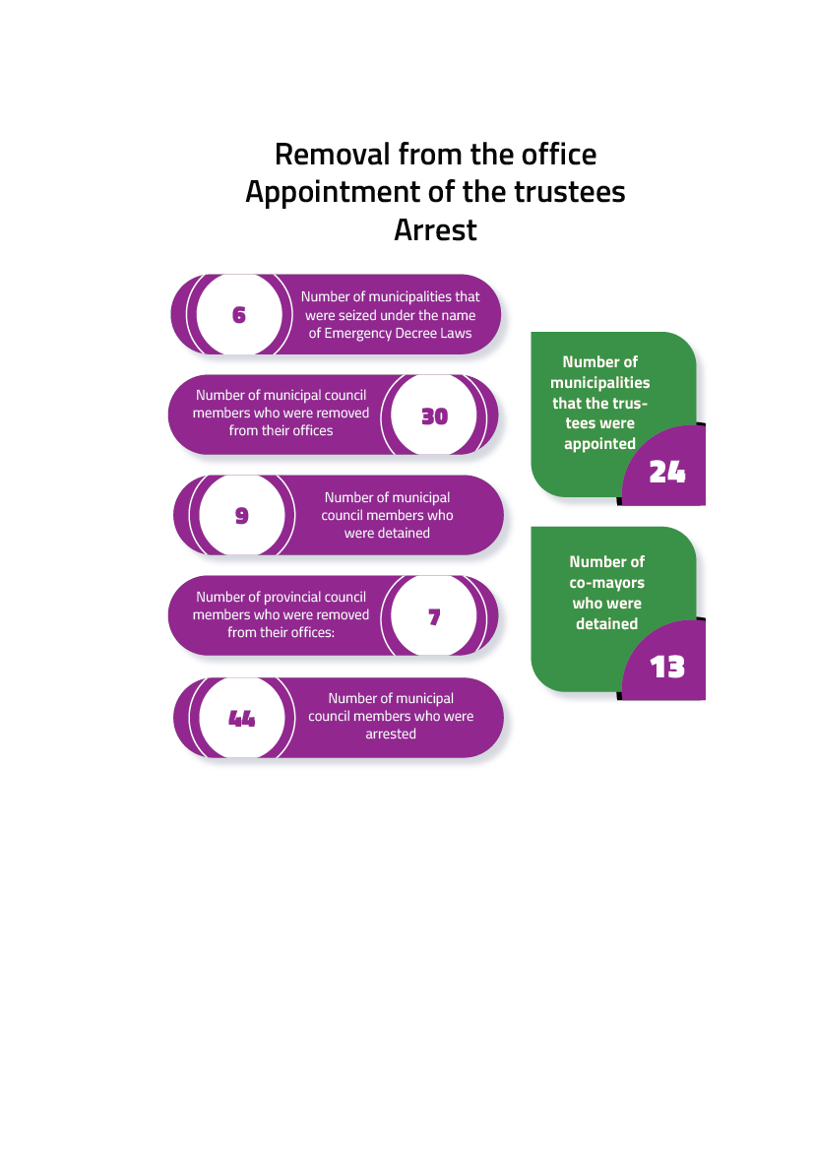

The appointment of trustees was not enough and did not stop the authorities so that the co-mayors of relevant municipalities were also arrested and then detained. Accordingly, the general situation that emerged after 31 March is as follows:

1. The municipalities which the trustees were appointed, the Co-mayors who were removed from their offices and detained:

* 19 August– 16 November 3 Metropolitan Municipalities, 1 Provincial Municipality, 19 districts and 1 county municipality, which makes 24 in total, were removed from their offices by the Ministry of Interior Affairs working the Erdoğan, who is the president of AKP, Government.
* The Governors and the district governors, who were appointed by the Government to these places and acted as high rank local authorities, were appointed (as the acting mayors) to the municipalities.
* 14 co-mayors were detained and sent to prisons.

1. The following list shows the municipalities, which we won yet were seized by the Supreme Board of Election’s decision. These co-mayors were not given the mandate though they official won the elections:

1. Mr Zeyyat Ceylan, the Co-Mayor of Bağlar Municipality in Diyarbakır,

2. Ms Leyla Atsak, the Co-Mayor of Çaldıran Municipality in Van

3. Ms Gülcan Kaçmaz Sağyiğit, the Co-Mayor of Edremit Municipality in Van,

4. Mr Yılmaz Berki, the Co-Mayor of Tuşba Municipality in Van,

5. Mr Müzahit Karakuş the Co-Mayor of Tekman Municipality in Erzurum,

6. Mr Abubekir Erkmen, the Co-Mayor of Digor-Dağpınar Municipality in Kars

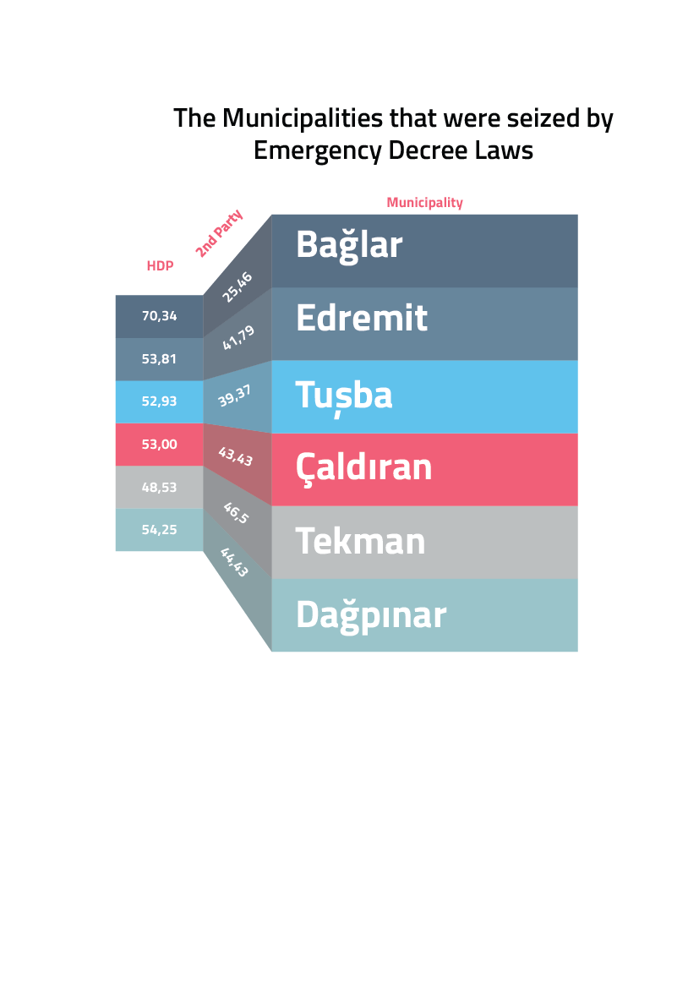

1. The co-mayors who were not given the mandate as a result of the Supreme Board of Election’s decision:

1. Ms Hülya Alökmen Uyanık, the Co-Mayor of Diyarbakır Metropolitan Municipality,

2. Mr İbrahim Çiçek, the Co-Mayor of Yenişehir Municipality in Diyarbakır,

3. Mr Necati Pirinççioğlu, the Co-Mayor of Yenişehir Municipality in Diyarbakır,

4. Ms Seher Kadiroğlu Ataş, the Co-Mayor of Hakkari Municipality,

5. Mr Salih Kuday, the Co-Mayor of Kızıltepe Municipality in Mardin,

6. Mr Yasin Kalkan, the Co-Mayor of Savur Municipality in Mardin,

7. Mr Resul Kaçar, the Co-Mayor of Siirt Municipality,

8. Mr Mahmut Pala, the Co-Mayor of Erciş Municipality in Van

1. As a result of the Supreme Board of Election’s unlawful decision, the mandate was not given to 44 municipal council members and 3 provincial council members *viz* 47 council members in total though they were elected. In fact, it was the seizure of their mandate.
2. From 31 March to 12 November, 30 municipal council members were suspended from their post.
3. From 31 March to 12 November, a total of 5 municipal council members and 2 provincial council members were detained and sent to prison. 7 provincial council members, who were elected in the 31 March local elections, were simultaneously suspended from their post on 9 September 2019.

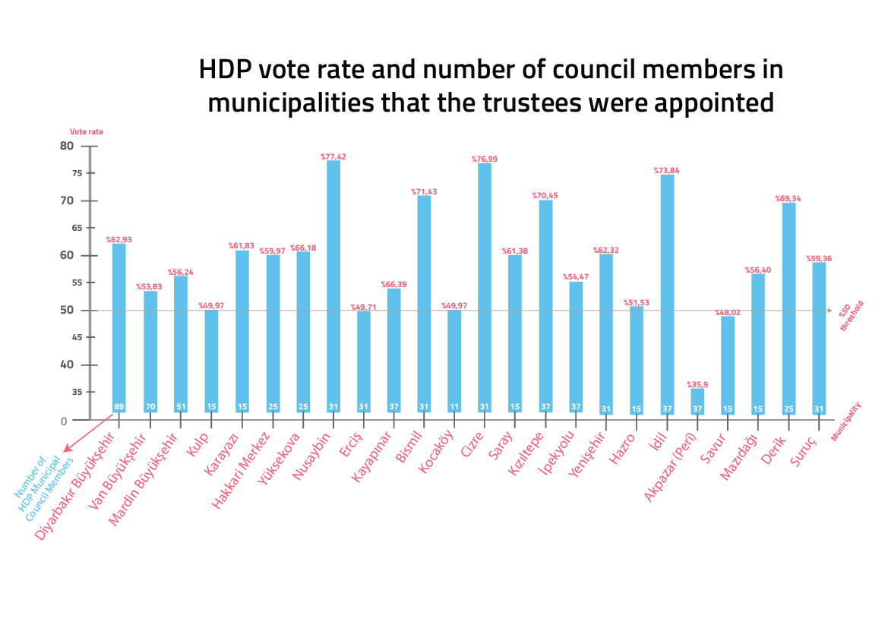

**Making the Council Member Nonfunctional**

With the appointment of a trustee to our municipalities and as a result of the fact that the trustees dissolved the municipal councils in a *de facto manner*, the municipal councils, which are local decision-making bodies, became nonfunctional and the will of all elected municipal councilors was seized.

The will of 319 out of 433 municipal council members, who were elected in the 31 March local elections, was seized since there was a de facto dissolution of the municipal councils. With the appointment of the trustees, it is not the will of the HDP council members but also members of the other political party was seized (See local section on "legal process" about this issue).

|  |  |  |  |
| --- | --- | --- | --- |
| **PROVINCE** | **DISTRICT** | **TOTAL NUMBER OF ELECTED MUNICIPAL COUNCIL MEMERS in 2019** | **TOTAL NUMBER OF COUNCIL MEMBERS FROM HDP** |
| DİYARBAKIR | Bismil | 31 | 26 |
| DİYARBAKIR | Hazro | 11 | 7 |
| DİYARBAKIR | Kocaköy | 11 | 8 |
| DİYARBAKIR | Kayapınar | 37 | 29 |
| DİYARBAKIR | Kulp | 15 | 10 |
| DİYARBAKIR | Yenişehir | 31 | 23 |
| DERSİM | Akpazar | 9 | 5 |
| ERZURUM | Karayazı | 15 | 12 |
| HAKKARİ | Yüksekova | 25 | 20 |
| HAKKARİ | Hakkari center | 25 | 18 |
| MARDİN | Nusaybin | 31 | 28 |
| MARDİN | Kızıltepe | 37 | 30 |
| ŞIRNAK | Cizre | 31 | 28 |
| ŞIRNAK | İdil | 15 | 14 |
| VAN | Saray | 15 | 11 |
| VAN | Erciş | 31 | 18 |
| VAN | İpekyolu | 37 | 24 |
| **TOTAL** | | **433** | **319** |

With the appointment of trustees to our metropolitan municipalities, as a result of the fact that the trustees dissolved the municipal councils in a *de facto manner*, the metropolitan municipal councils, which are the local decision-making bodies, also became nonfunctional and the will of the council members were seized.

The metropolitan municipal councils are composed of one-fifth of district mayors and district municipal council members located in the metropolitan municipality borders. With the appointment of a trustee in our metropolitan municipalities, with the fact that the council was dissolved in a *de facto manner* by the trustee, it is not the will of the HDP council members but also members of the other political party was seized.

In this respect; A total of 174 metropolitan municipal council members, including 74 elected members from the Diyarbakır Metropolitan Municipality Council, 43 elected members from to the Mardin Metropolitan Municipality Council, and 57 elected members from the Van Metropolitan Municipality Council, have removed from their office in a *de facto* manner.

|  |  |  |
| --- | --- | --- |
| **Province** | **Type of the Municipality** | **Number of Municipal Council Member** |
| DİYARBAKIR | Metropolitan | 74 |
| MARDİN | Metropolitan | 43 |
| VAN | Metropolitan | 57 |
| **TOTAL** | | **174** |

Women were particularly targeted by these systematic intimidation practices against the municipal council members. In addition to the fact that they were subjected to degrading treatment in house raids and they under poor conditions while being held under arrest.

Similarly, 8 of 14 detained Co-Mayors are women. As it is known that, according to the results of the local elections on 31 March, 1389 mayors were elected and there were 45 women who were elected. 24 out of 45 women mayors are from HDP. In other words, HDP is a very important party regarding the women representation in the political life since it has has 53.5 percent female mayors that is the highest percentage in Turkey.

It is not surprising that the majority of our detainees are women. In particular, there are attacks on the co-mayorship System, which is considered as the ‘purple line’, through judicial and black propaganda, and it is being deliberately criminalized. The AKP-MHP coalition showed the co-mayorship system as a reason for the coup on 19 August. The main reason for the targeting of the Co-Mayorship structure is the insistence on male-dominated politics that does not recognize but and reject the equal representation right.

While the number of women and men constituting the society is almost equal, the fact that women are almost non-existent in the society’s administration processes is clear evidence about the male-dominated understanding in administration process. Since there cannot be a society without women, it is evident that the administration systems based on the male-dominated approach have no “society” and do not represent the real society. In this respect the co-presidency model, which we apply and defend as one of the main mechanisms of our political party, is one of the fundamental indicators of our principle of equal representation.

With regard to the political parties represented in the Grand National Assembly of Turkey, HDP is the only party that has adopted and practiced “Co-Presidency” at the level of the Presidency. The Co-Presidency model is a legitimate form of organization, which is in under guarantee of the law-thanks to the long struggle-albeit at the Presidency level. Therefore, the model is not under the guarantee of law with regard to the provincial and district levels of the party organization.

While the Co-Presidency model is not fully under the guarantee of the law in Turkey, it is progressive and successful model that HDP has adopted in a *de facto* manner so as to ensure women's political participation in the fair and equal representation in politics. It is implemented in district and provincial offices levels.

Our party does not have a cosmetic approach to women's representation in politics, therefore; it is interested in co-presidency system at the presidency level only. In regard to the female representation in the TGNA, HDP has the highest rate of female MPs among the parties represented in the parliament. The AKP government, one of the clearly manifested representatives of the male mentality, makes propaganda to the country and the world that the Co-Presidency model, which we implement in our municipalities, is a criminal case. Thus, showing this model as a crime is unlawful, illegitimate and contrary to the facts in any society.

When HDP demanded to run municipalities during the pre-election period, the concept of “Co-Mayorship” was discussed by all actors in all levels namely from the selection of candidates, to asking vote from the people, all kinds of election materials were prepared in accordance with this concept. This is how HDP won such a huge support from the people. The Co-Presidency and co-mayorship system are the social names of the stage that women's struggle has reached.

**LEGAL PROCESS**

**“Destroying law through unlawful practices”**

We would like to state that Kurds’ rights to vote and to be elected were taken away from their hands in municipalities that the trustees were appointed and the Kurds are virtually deprived of citizenship as well. The legal status of the co-mayors who were dismissed and replaced with trustees, the charges against our co-mayors are not related to their municipal duties. In other words, these charges do not include any issue related to municipal services such as providing services to citizens, protecting their rights and activating their participation. These charges mainly fall into the scope of freedom of expression and thought since there are statements made in the capacity of political party representatives. The detention of the co-mayor is built upon probabilities and is based on statements of the secret or open witnesses that are not accepted by the Court of Cassation.

For example, the witness-who name is Hicran Berna Ayverdi-made statements against Mr Adnan Selçuk Mızraklı, the Co-Mayor of Diyarbakır Metropolitan Municipality, and Ms Keziban Yılmaz, the Co-Mayor of Kayapınar Municipality. Berna Ayverdi surrendered to authorities in Nusaybin district in May 2016. Her statement against the co-mayors dated 20.03.2019 that is 11 days before the elections. After 3 years in prison, she made this statement right before the elections. Although she was detained for three years, she made a confession on 20 March 2019 so that she would benefit from the repentance law. In her statement, she said that Mr Mızraklı operated on a member of organization in the night shift at the hospital where Mızraklı was working as a doctor, cut his guts and discharged the member of the organization in the following morning. More problematically, she states that she did not see this event but a friend of her had told it. Therefore, there is neither an incident nor a witness.

Selçuk Mızraklı in a statement said[39]: “I do not accept such claims. Since I was a senior surgeon, I did not have any shift at the hospital. The witness mentioned that the patient's intestine was cut and removed. Being a medical doctor for 40 years doctor, and according to medical rules, what I know is that any person who has such an operation cannot be discharged on the following day since it is against the usual flow of life and medicine.”

Ms Keziban Yılmaz was detained upon the statements that Berna Ayverdi had made 4 days before the local elections. Ms Yılmaz is charged with criminal offence and faces the risk of imprisonment for decades for attending the “HDP candidate promotion meeting for women candidates for co-mayorship post and for saying Leyla Güven was on hunger strike[40]and ‘municipality buildings were transformed into police stations’.”

The confessor Ayverdi was sentenced to the aggravated life imprisonment in prison yet she was released in September 2019 thanks to her 'confession'[41]. While the same person made confessions about two other people in 2017 were not regarded as credible by another court, her statements against the co-mayors were accepted by the court (most probably for being political figures). Ayverdi was released from the Kayseri prison where she was detained, and ironically Mr Selçuk Mızraklı and Ms Keziban Yılmaz and Ms Rojda Nazlıer were taken to the same prison in Kayseri. They were subjected to torture methods in the prison vehicle while they were being taken from Diyarbakır to Kayseri.[42]

Similar scandals took place in case of the detention of Co-mayors of Yüksekova Municipality. S.K, who made statements against almost everyone in Yüksekova and was not respected by the courts, was taken into consideration when the statements were about Co-mayors. The interesting point of this case is that the witness, who said that he had previously made the statement under police pressure, has been in prison for 9 years[43]

Another Co-mayor Ms Remziye Yaşar is in prison for committing a very serious crime (!), She was detained and sent to prison for sharing Tolstoy's sentence “War is not a festive with spear or trumpet” She was detained for sharing this sentence with a hastag that says “#Notowar.”

What happened in Van Ipekyolu Municipality is a simple reflection of the arbitrary state regime. The Co-Mayors of İpekyolu Municipality were detained on basis of the evidence, that is an article published in a local newspaper called (Van Post) in the Province of Van. The columnist named Ziya Türk’s slander was shown as a reason for this detention although his article was declared by the court “there is no media report quality but slander and insult against people in his writings” so that it is a piece of paper without intention of credible media report. After the appointment of the trustee to the municipality, this person began working for the municipality as the press manager.[44]

While the charge against the Co-mayor of Cizre Municipality was still in the process of prosecution, it was used to justify the appointment of the trustee to the municipality. Similarly, a trustee was appointed to the municipality while Ms Caziye Duman, the Co-mayor of Saray District in Van. The Co-mayor of Kızıltepe Municipality does not have an investigation file though a trustee was appointed to the municipality.

Even if the co-mayors, who are charged with an offense, are removed from their office as part an interim measure, in accordance with the Municipality law, the municipal council has the authority and assurance to elect the new co-mayor to the municipality among its council members. However, these dismissals take place with no respect for legal and legislative obligations and rights, and municipal councils are dissolved in a *de facto* manner.

**The Elimination of the right to vote and to be elected**

As the Diyarbakır Bar Association states in its report on human rights violations in August, the right to vote and to be elected refers to two separate political rights namely the right to elect someone and the right be elected to the state administration so that the possibility to take part in administration is realized.

From the positive law perspective, the law rules applied in Turkey is not valid only in this country. Moreover, international conventions on fundamental rights and freedoms, which have been duly adopted, have also the power the law, and are even constitutionally considered as supreme provisions. In this point of view, while assessing normative law, international conventions particularly the European Convention on Human Rights, to which the Republic of Turkey is a state party, and the European Court of Human Rights’ law case that Turkey has accepted the jurisdiction should be considered.**[45]**

Article 90/4 of the 1982 Constitution, of which title is “Ratification of International Treaties”, states “International agreements duly put into effect have the force of law. No appeal to the Constitutional Court shall be made with regard to these agreements, on the grounds that they are unconstitutional. (Sentence added on May 7, 2004; Article 7 of Act No. 5170) In the case of a conflict between international agreements, duly put into effect, concerning fundamental rights and freedoms and the laws due to differences in provisions on the same matter, the provisions of international agreements shall prevail.” The Constitution states that international agreements shall be accepted as a higher norm in hierarchies of norms.

**The Denial of the denied: Trusteeship**

The Ministry of Interior Affairs' decisions about the appointment of trustees and the removal of the mayors from the office violate Articles 2, 38, 67, 123, and 127 of the Constitution and Article 47 of the Law No. 5393, and several Articles, particularly Article 4/4, of the European Charter of Local Self-Government to which Turkey is a party.

First of all, the Ministry of Interior Affairs' decision about the dismissal of mayors is based on Emergency Decree Law No. 674 that was issued during the State of Emergency. The Emergency Decree Law No. 674, which has regulations on the Law on the Ministry of Interior Affairs' Organization and the Municipality Law, has made a certain distinction between investigations and prosecutions related to terrorism; has given the authority to "appoint” [a trustee] to the Ministry of Interior Affairs in case of provincial municipalities and to the Governor in the districts municipalities. These regulations, which came into force with the Emergency Decree Law under the State of Emergency, has become an official law and gained a permanent status following the parliamentary debate and it has been adopted by the Parliament. On the other hand, this provision is open to debate since it was not submitted to the approval of the TGNA within the required time period and declared an official law without constitutional review.

The regulation, which was adopted during the State of emergency and obtained the permanent law status later, is clearly contrary to the Constitution. In other words, the Emergency Decree Law issued under the State of Emergency puts some restrictions on Article 45 of the Municipality Law that is a body's authority to determine the president though the body is constituted in accordance with Article 127 of the Constitution. This regulation constitutes a blatant violation of the Constitution. It is a violation because the dismissal procedure and the removal of the title of an organ, are clearly regulated by Article 127 of the Constitution that says "*Loss of status and objections regarding the acquisition of the status of elected organs of local administrations shall be decided* ***by judiciary****.*" All these procedures and removal of the title of an organ were carried out without any judicial review.

Moreover-in spite of the aforementioned irregularity-the municipal council that is the decision-making body of the municipality is still authorized to elect new bodies. Furthermore, the appointment of a trustee instead of an election is a violation of Article 123 of the Constitution of which title is "Integrity of the administration and public legal personality." The Article 123 states "The organization and functions of the administration are based on the principles of centralization and decentralization." In conjunction with this Article, there is also the violation of Article 2 of the Constitution that regulates the principle of the rule of law. On the other hand, although this regulation has been adopted as a law, it had been issued as a measure under the State of Emergency and for the period in question. Therefore, when the State of Emergency was removed, it lost its power as well. Because the State of Emergency practices and measures can be implemented during the period of the State of Emergency only. Thus, this practice is contrary to the law and the Constitution.

Furthermore, Article 127 of the Constitution and Article 47 of the Municipality Law No. 5393 regulate the same issue. Article 127 of the Constitution states that the Loss of status and objections regarding the acquisition of the status of elected organs of local administrations shall be decided by judiciary. However, there is an exception in this respect, that is regulated by Article 47 of the Law no. 5393. The Article stipulates that municipal bodies or members of these bodies who have been investigated or prosecuted for an offense related to their duties might be suspended by the Minister of Interior Affairs until the final decision is made by the court. When we look at the interpretation of the provision, the first point is that the text of the law on mayors states that they "might be suspended" not "shall be suspended" and provides a margin of discretion to the Ministry of Interior Affairs. The Ministry of Interior Affairs should not use discretion power in a way that is incompatible with democracy.

In order to harmonize our legislation with the European Charter of Local Self-Government, to which our country is a state party, and to protect the autonomy of the local administrations, the conditions to be applied to the dismissal authority, which is granted to the central administration, and the rules to be followed during the continuation of this period are also regulated by this Article. The authority under Article 127 of the Constitution and Article 47 of the Law on Municipality shall apply to mayors, who have committed criminal offenses and have been subjected to an investigation, **following their election**. The investigations and prosecutions, which the Ministry of Interior Affairs showed as the ground for its decision to removal the mayors from their office, are from the pre-election period and there is no final court decision yet. Since the investigations and prosecutions belong to the pre-election period, they cannot be shown as a reason for dismissal.

Similarly, the removal of the mayors from their office and appointment of the trustees to their office without a final court decision and paying attention to the fact that criminal investigations and prosecutions were launched before the local elections violate the presumption of innocence defined in Article 38 of the Constitution. In addition, the Ministry of Interior Affairs’ reasons for dismissal of the mayors and appointment of trustees to the municipalities have no concrete information, documents or evidence. It has become clear that these decisions, which are abstract and have no evidence, demonstrate such arbitrary removal from the office and trustee appointments can take place at any time.

The dismissal of the Mayors is a blatant intervention in the Supreme Board of Election’s mandate and the judiciary since these co-mayors were not prevented from running for the elections by the Supreme Board of Elections and become a candidate, and they obtained their mandate with no problem. Yet, they were removed from their office in less than 1 year. These dismissed mayors obtained their mandate in accordance with the election results announced and approved by the Supreme Board of Election. That is to say, the dismissal of the mayors, who were not deemed inappropriate for being a candidate by the Supreme Board of Election and were able to obtain their mandate following their elections, by an administrative decision-while it has no concrete reason and legal basis, constitutes a violation of the right to vote and to be elected. These rights are granted to citizens and under the protection of Article 67 of the Constitution.

On the other hand, from the ECtHR law case perspective, the “**legitimate expectation principle**”, which is part of the right to vote and to be elected and one of the rights under the guarantee of Article 3 of the 1st Protocol for a genuine democratic system, has been ignored by these decisions as well. As a matter of fact, the principle of legitimate expectation provides the vested rights to the co-mayors, who were not deem inappropriate and declared as having no obstacles to their candidacy by the relevant authority in this case the Supreme Board of Election, and to voters because they were elected in accordance with the relevant body’s approval. The dismissal of the co-mayors with no concrete reasons also means that the guaranteed rights are arbitrarily violated and the society is misled.

There is an attempt to naturalize the practice of trustee appointment is clearly contrary to the European Charter of Local Self-Government’s following provision, which Turkey has committed to abide, "normally, *powers given to local authorities shall be full and exclusive. Except for cases as provided by law, these powers may not be weakened or limited by other central or regional authorities.”* Turkey has also disrespected its commitment to the provision. It needs to be highlighted that the unlawfulness present in the decision about the trustee appointment is the multi-dimensional.

Indeed, the investigations and prosecutions, which are shown as a reason for the dismissal of mayors, are irrelevant to this measure since they were launched before the local elections. In other words, it is contrary to Article 127 of the Constitution which says “offences related to their duties after they are elected.” With the coup d'état on 19 August 2019, the Co-mayors of the HDP were unlawfully criminalized and dismissed from their posts by the ruling party, and a trustee was appointed to their office. In order to justify these dismissals, these co-mayors were detained and sent to prison as a result of “fabricated reasons” for membership of an organization.

Since the Emergency Decree Laws obtained the permanent law status, it is obvious that the trustee appointment, which is regulated in the legislation in Turkey, shall be arbitrarily used and justified by the authorities. With the permanent provision for the trustee appointment, (the regulation added to Article 45 of Law No. 5393), a new rule has been introduced to the legislation. The new rule states “in these municipalities, the municipal council cannot meet unless the mayor (trustee) calls for a meeting, and the duties and powers of the council, committee and commissions are carried out by the civil servants (appointed member). Thus, there is not only elimination of right of the mayors to be elected but also the prevention of the municipal council meetings. That is to say the citizens’ constitutional rights, namely the right to vote and to be elected, were taken away.

**With regard to the European Charter of Local Self-Government**

As it is known, the development of democracy is directly related to the strengthening of local administrations, the providing qualified services, and the citizens’ ability to exercise their right to vote under free and equal conditions. Providing a more libertarian and autonomous structure of the of local administrations on the basis of the international law particularly the European Charter of Local Self-Government and the revision of the 5393 law and related legislation, will be an important step to solve may fundamental problems and establish democracy in Turkey.

In this respect, there are several approaches and legal arrangements have been implemented and deteriorated the local democracy and thus general democratic measures especially in the recent period. In particular, the central government the intervention in local administrations by the trustees has significantly eliminated the local democracy. However, Turkey has signed the European Charter of Local Self-Government on 21 November 1988; in 1992, it is guaranteed by Law No. 3723 adopted by the Parliament. In this context;

1. Article 4 of the European Charter of Local Self-Government, which is guarantee, covers autonomous local administrations and rejects "they [local administration] may not be undermined or limited by another, central or regional, authority except as provided for by the law. However, with the addition of the Decree Law no. 674 to Article 45, the power to suspend the mayors and to appoint trustees even with no need to have any court decision." Therefore, the local administration was "weakened" and "limited.”
2. Article 5 of the Charter stipulates "Changes in local authority boundaries shall not be made without prior consultation of the local communities concerned, possibly by means of a referendum where this is permitted by statute." The constitutional government in Turkey is defined as "central government" and "local administration". With the appointment of trustees, the powers of the mayor and the municipal council viz the local administrators, are transferred to the governors in the provinces and to the district governors in the districts though they were appointed by the government. Therefore, the transfer of powers from of local authorities and taking these authorities from the elected people, and to the appointees directly affects the citizens for whom the local administrations served. While these fundamental changes need to be presented to the citizen's opinion, through a "referendum" or "consultation processes" with the direct participation of citizens, the appointment of the trustee from the central government prevents citizens from to be a prisoner.
3. Article 6 of the Charter states that "local authorities shall be able to determine their own internal administrative structures in order to adapt them to local needs and ensure effective management." This statement makes the relationship between the central government and local structure and local administration will be able to meet its needs. In line with this provision, general principles are pointed out in the law. It is ensured that local administrations can make their own decisions about their internal administrative structures and to make these administrations efficient. Yet, the administrative measures by our municipalities within this framework are either rejected by the governors or they are subjected to investigations.

The Co-Mayor system is also directly linked to this Article. Co-Mayor covers the implementation of a social need in the elections without being approved and changed without damaging the central administrative structure. It is also approved as an internal administrative structure in municipal councils. Therefore, launching a judicial and administrative investigation is contrary to the Convention of which Turkey is a state party.

1. The Additional Protocol to the European Charter of Local Self-Government on citizens 'right to participate in the management and administration of local administration affairs regulates citizens' right to participate. Accordingly, Article 1, paragraph 1, “The States Parties shall secure to everyone within their jurisdiction the right to participate in the affairs of a local authority.”The second paragraph reads as follow The right to participate in the affairs of a local authority denotes the right to seek to determine or to influence the exercise of a local authority's powers and responsibilities.”

The third paragraph notes "The law shall provide means of facilitating the exercise of this right. Without unfairly discriminating against any person or group, the law may provide particular measures for different circumstances or categories of persons. In accordance with the constitutional and/or international obligations of the party, the law may, in particular, provide for measures specifically limited to voters." Therefore, the right of each citizen to be elected has the right to participate directly or indirectly in local government. The right to participate in local administration in Turkey includes the basic citizenship rights of the individual such as being a free candidate and voting freely. Therefore, local councils are the most effective and competent decision-making body for citizens' the participation of citizens in administration. This right is guaranteed by the Constitution and the Municipal Law No. 5393. Article 17 of Law No. 5393, “Municipal Council is the decision making organ of the municipality and is formed by the members selected according to the principles and procedure set-forth in the relevant law.” Furthermore, Article 18 of the same law sets out the duties and powers.

However, with the additional provision introduced to the Law No. 5393 by the Emergency Decree Law has been rearranged as follow "In these municipalities, the municipal council cannot convene unless the president calls. The duties and powers of the Assembly, the Council and the Commissions shall be carried out by the members of the Council specified in Article 31”. No council meeting is held in any municipality appointed under the trustees, and all powers are carried out by appointed officers appointed by the trustee.

The *de facto* dissolution of the municipal councils, through which the citizens are entitled to exercise their right to participate in decision-making processes at the municipal level, is the deprivation of these citizens’ right to participate in local elections. Therefore, there is situation that the voters’ legitimate representative is not present but there is a municipality in the form of being and enhanced police stations.

**The Case of GABB: The Regime’s limits of seizure[46]**

On 19 August 2019, the Mayors of the Diyarbakır, Mardin and Van Metropolitan Municipality were suspended from their offices for 2 months and the Governors were appointed as trustees. Since Mr Adnan Selçuk Mızraklı, the Mayor of Diyarbakır Metropolitan Municipality, was also the President of the Union of Southeastern Anatolia Region Municipalities, the Governor of Diyarbakır was appointed as a trustee also to the Union in a completely way contrary to the local democracy and aims of the union.

The appointment of the trustee, who is in charge of the Diyarbakır Metropolitan Municipality, as the President of the Union is contrary to the Union's Statute and the Law on Municipality No. 5393. The President of the Union is the head of the Union administration and the representative of its legal personality. He is the key manager and representative of the Union. Article 14 of the Law on Municipalities states “With regard to the termination of the President of the Union's mandate, the provisions for termination of the mayor's mandate for reasons other than attendance shall be applied."

With regard to the vacancy in the post of mayor, Article 45 states “In case of vacancy in post of Mayor bound to any reasons, the Governor shall call the municipal council for a meeting within ten days. The Municipal Council shall convene under the chairmanship of the first vice-chairman, or in his absence, second vice-chairman, or the oldest senior member.

a) A mayor in case of vacancy in the post of Mayor, or imposition of punishment restricting him from public service in such a way to exceed the election period,

b) A deputy mayor in case of suspension of the Mayor from office or imposition of punishment restricting him from public service in such a way not to exceed election period.”

The GABB Assembly held its first meeting on 21 June following the 31 March local elections and held elections for the Presidency of the Union, the Presidential Council, commissions and councilors. The election results are as follows: Mr Selçuk Mızraklı, who is also the Co-Mayor of Diyarbakır Metropolitan Municipality, won 110 votes and became the President of the Union. Although the Governor of Diyarbakır, Mr Hasan Basri Güzeloğlu, who was appointed as the trustee to the Diyarbakır Metropolitan Municipality, has no authority and there is no provision to be applied in this case, has appointed himself as the Acting President of the GABB and clearly committed a crime. And, he continues to commit this crime.

Hasan Basri Güzeloğlu, the trustee, did not attend the GABB Assembly meeting held on 30 September. Rather, he sent the deputy governor to the meeting that is another irregularity and a crime. Due to the suspension of Adnan Selçuk Mızraklı, who was elected as the President of the Union, Ms Songül Korkmaz, the Co-Mayor of Batman Province and the 1st Acting President of GABB opened the Union Assembly meeting. In accordance with the provisions of Article 14 of the GABB Statute, on behalf of HDP Council members, a motion for the election of the new President of the Union was submitted to Council. As a result of voting, the motion was accepted by the Council. Following the adoption of our motion, a member of the Union from AKP (Sirnak Mayor) stated that the Deputy Governor would speak. The members of our party objected to this request since the Deputy Governor had even no right to attend the meeting as the representative of Mr Hasan Basri Güzeloğlu, the unlawfully appointed trustee, let alone to speak. Mr Ahmet Kaya, the co-mayor of Ergani Municipality, made a detailed speech about this issue. Despite all objections, the Deputy Governor took the floor-to some extent invaded the stage-and said: “I am here on behalf of the state and I would not let you to organize any voting.” He made a statement, which is contrary law and legislation, and said “the Union has a president and the president is the governor.”

Following the removal of Mr Adnan Selçuk Mızraklı from the Mayor of Diyarbakır Metropolitan Municipality in an unlawful manner by the Ministry of Interior, he was unlawfully removed also from his office as the President of the Union. The trustee was appointed to this position, as well. As Article 45 of the Law on Municipality requires and the Union’s statute points out that the President of the Acting President of the Union should have been elected among the Union members. Rather than this procedure, the trustee of the Diyarbakır Metropolitan Municipality was appointed the trustee to the GABB in an absolutely unlawful manner.

**As a conclusion...**

The Congress of Local and Regional Authorities released its report on Turkey, which covers Local elections in Turkey and Mayoral re-run in Istanbul (31 March and 23 June 2019) and has been adopted by overwhelming majority within the scope of the 37th Congress in late October. The report draws attention to the trusteeship issue in particular it states that it is unreasonable and unacceptable that some mayors were subsequently disqualified from taking office after they had been elected and the second placed candidates were appointed, the council members were not involved in this process. Similarly, the report notes that security officers voted in specifically certain locations, media coverage was limited for certain political parties. All these points show this overt seizure to the whole world.[47]

The series of unlawful actions, of which chronicle shown since 31 March 2019, is a real coup d’etat against the local administrations. When we carefully think about the mentality of this coup d’etat, which is an issue for the democracy across Turkey, it is obvious that the ground- through which the municipalities and local administrations can be taken from the elected people also in other cities-has been created in Kurdish provinces.

It is terrifying to observe what happed to the elected people in this regard. It becomes more terrible to pay attention to the actors of these policies and practices since they are proud that they obtained power through elections. The trusteeship issue is a clear indicator of the Government’s in other words AKP-MHP’s seizure and enmity-oriented approach to the Kurds and democracy. In this regard, the appointment of trustees and seizure of the will should not be interpreted as a temporary or as a matter of this period issue only. There is a considerably ideological, historical and long background of these practices. These policies and practices are the continuation of the traditional State policies about the Kurdish people. On the other hand, it needs to be noted that biddings, the desire for conquer, the distribution of unearned income, and the plunder. Whenever it is about the seizure of the Kurds’ democratic rights, all unlawful attacks are justified.

The general results of the appointment of trustees include attacks against women’s achievements that amount to the femicide; assimilation practices under the name of social policies; desire for Turkification in the case of the Kurdish identity and culture; the mentality to make people dependent on [the system]; worsening the economic situation of poor people so that they become poorer; creating a huge whirlpool of inequalities. We would like to note of these facts in history.

1. The Civilian spectors’ report: Mayors should be appointed by the President.  
   <https://bit.ly/2NJhYa5> - <https://bit.ly/2KAlcej>
2. HDP Trusteeship Report – (It was banned by the Criminal Peace Judgeship in Siirt)-15.03.2019  
   <https://www.hdp.org.tr/tr/raporlar/hdp-raporlari/kayyim-raporumuz/12907>  
   
3. Turkish Court of Accounts’s filing complaint files! <https://bit.ly/34Jy759> , Corruption issue:<https://bit.ly/2K8VT2F>  
   (For other practices see: Footnote 3 and 4)
4. Kayyım atamalarının yarattığı hukuksuzluk ve yolsuzluk çarkına ilişkin önerge  
   <https://www.hdp.org.tr/tr/guncel/meclis-calismalari/kayyim-atamalarinin-yarattigi-hukuksuzluk-ve-yolsuzluk-carkina-iliskin-onergemiz/13706>
5. Trustees were rewarded  
   <http://www.yeniyasamgazetesi1.com/kayyumlar-batiya-atandi/>
6. The Trustee Report for Women issues, it was established on 7 March 2019 in an event in Van province:  
   <https://www.hdp.org.tr/tr/raporlar/hdp-raporlari/kadin-kayyim-raporumuz/12932>
7. Detailed report on moving and merging the ballot boxes: <https://www.hdp.org.tr/images/UserFiles/Documents/Editor/Sandik_tasima_rapor_2019.pdf>
8. Erdoğan: We would appoint trustees if they are re-elected.   
   <https://www.ahaber.com.tr/gundem/2018/10/07/baskan-erdogan-ankarada-konusuyor>
9. Erdoğan: We would appoint trustees if needed!   
   <http://www.gercekizmir.com/haber/Erdogan-Gerekirse-yine-kayyum-atariz/59810>
10. Security officers voted in Şırnak  
    <https://ozgurmanset.net/iste-sirnaktaki-tasimali-asker-ve-polislerin-sandik-sonuclari/>

   
11. Registering 1108 voters in 1 house in Hakkari. <https://tr.sputniknews.com/columnists/201901141037085904-hakkaride-bir-daireye-1108secmen-kaydedilmis/>
12. Luxury expenditures of the trustee in Diyarbakır Metropolitan Municipality  
    <https://twitter.com/SelcukMizrakli/status/1118124319559835649>
13. Ordering Turkish style gabel from Uşak province to Diyarbakır  
    <https://bit.ly/375vxbF>
14. Some documented examples of plunder in Mardin  
    <https://t24.com.tr/haber/ahmet-turk-kayyum-16-masasi-bulunan-lokantaya-1-milyon-75-bin-216-tl-hesap-odedi,836933>
15. Gifts, which costs 600.000 Turkish lira, to the AKP ministers  
    [https://www.dw.com/tr/mardinde-kayyumdan-akpli-bakanlara-600-bin-liral%C4%B1k-hediye/a-50157693](https://www.dw.com/tr/mardinde-kayyumdan-akpli-bakanlara-600-bin-liralık-hediye/a-50157693)
16. There are some municipalities, which we won in the last local elections, run by AKP. For example, the provincial municipality in Kars and the district municipality in Kurtalan. The level of debt is too high in these municipalities, too.
17. 1+1 Forum sitesinde -Express journal- Interview with the Co-Mayors of Yüksekova  
    <https://www.birartibir.org/siyaset/481-paranin-izini-surmek>
18. Co-mayors, who were dismissed from the public service, make their analysis of the situation after their mandate was not given  
    <https://www.bbc.com/turkce/haberler-turkiye-47890075>
19. The Chief of Security Officer: I act in a manner contrary to law <https://www.gazeteduvar.com.tr/gundem/2019/05/08/emniyet-muduru-kanuna-aykiri-hareket-ediyorum/>
20. The Governor’s Office requested and the Ministry acted: 9 HDP council members were removed from their post.  
    <https://ahval.me/tr/hdp/valilik-istedi-bakanlik-yapti-hdpli-9-belediye-meclis-uyesi-gorevden-uzaklastirildi>
21. Remove your hands from our municipalities, the will of people, and our children <https://www.hdp.org.tr/tr/basin/basin-aciklamalari/belediyelerimizden-halk-iradesinden-ve-cocuklarimizdan-ellerinizi-cekin/13191>
22. Parliamentary questions were submitted to investigate the police intervention in the Co-Mayors of Diyadin Municipality <https://www.hdp.org.tr/tr/guncel/meclis-calismalari/diyadin-belediye-esbaskanlarimiza-yonelik-polis-siddetine-iliskin-onergemiz/13295>
23. A minor contribution to the dictatorship theory: Ernst Fraenkeland the Dual State [https://www.academia.edu/37582122/Diktat%C3%B6rl%C3%BCk_Kuram%C4%B1na_Bir_Katk%C4%B1_Ernst_Fraenkel_ve_%C4%B0kili_Devlet](https://www.academia.edu/37582122/Diktatörlük_Kuramına_Bir_Katkı_Ernst_Fraenkel_ve_İkili_Devlet)
24. The Supreme Board of Election announced its reason for the cancellation of the election  
    <https://www.bbc.com/turkce/haberler-turkiye-48304527>
25. The temporary mayor has been announced!   
    <https://bit.ly/2qUalos>
26. HDP's call for “strategic vote” for elections in İstanbul   
    <https://tr.euronews.com/2019/06/22/hdp-den-istanbul-secimleri-icin-stratejik-oy-cagrisi-demirtas-ocalan-23-haziran>
27. Trustees were appointed to the Metropolitian Municipalities in Diyarbakır, Van and Mardin Provinces <https://www.evrensel.net/haber/385094/diyarbakir-van-ve-mardin-belediyelerine-kayyum-atandi>
28. What happed in the morning that trustees were appointed.  
    <https://www.youtube.com/watch?v=jmd3XIs2yX4>
29. Statement about the removal of the Mayors of Metropolitan Municipalities in Diyarbakır, Mardin and Van  
    <https://www.icisleri.gov.tr/diyarbakir-mardin-van-buyuksehir-belediye-baskanlarinin-gorevden-uzaklastirilmasina-dair-basin-aciklamasi>
30. We did not remain silent and we will not stop!  
    <https://www.hdp.org.tr/tr/basin/basin-aciklamalari/susmayacagiz-durmayacagiz/13403>
31. It is revealed that the request for trustees was submitted even before the mandate was given to mayors <http://mezopotamyaajansi22.com/search/content/view/66740?page=1&key=efccb5cad41557a7cdf05694e706fabb>
32. The trustees, who order 'snacks’ acted on 1st April, as well. <http://mezopotamyaajansi22.com/search/content/view/66811?page=1&key=efccb5cad41557a7cdf05694e706fabb>
33. Police violence against the people  
    <https://www.youtube.com/watch?v=nEf7BPUJqC0>
34. Police violence in Van!   
    <https://www.gazeteduvar.com.tr/gundem/2019/08/21/vanda-kayyim-protestosuna-polis-siddeti/>
35. 145 people were arrested in 18 days in Diyarbakır   
    [https://www.dw.com/tr/diyarbak%C4%B1rda-18-g%C3%BCnde-145-g%C3%B6zalt%C4%B1/a-50319048](https://www.dw.com/tr/diyarbakırda-18-günde-145-gözaltı/a-50319048)
36. Protests against the trustee appointments were banned (10.10.2019)  
    <https://www.tigrishaber.com/kayyum-protestolari-yasaklandi-58751h.htm>
37. A trustee was appointed to the Municipality in Kulp District  
    <https://bit.ly/33MvMGE>
38. A trustee was appointed to the Municipality in Karayazı District!  
    <https://bit.ly/2qHEjvQ>
39. Letter from A. Selçuk Mızraklı  
    <http://mezopotamyaajansi22.com/tum-haberler/content/view/76208>
40. ‘Güven is on hunger strike' statement is accepted as an evidence for the court case  
    <https://bit.ly/370G5sm>
41. The confessor who made statements against, Mr Mızraklı and Ms Yılmaz, was released  
    <https://bit.ly/2CFwHfY>
42. The detained mayors were taken to the prison while they were handcuffed for 10 hours  
    <https://gazetekarinca.com/2019/11/tutuklanan-belediye-esbaskanlari-10-saat-boyunca-kelepceli-sevk-edilmisler/>
43. The ‘witness’ who led to the detention of co-mayors has been in prison for 9 years<http://yeniyasamgazetesi1.com/esbaskanlari-tutuklatan-tanik-9-yildir-cezaevindeymis/>
44. The Co-Mayors of İpekyolu: To the Press and Public  
    <https://bit.ly/2OfkBPV>
45. Diyarbakır Bar Association’s Report in August  
    <https://bit.ly/2rGCUGf>
46. GABB Statute  
    <http://www.gabb.gov.tr/birlik_uyelik.php?mid=1>
47. Congress of Local and Regional Authorities’ Report on Turkey:  
    <https://www.coe.int/en/web/congress/-/turkey-congress-adopts-report-on-the-observation-of-local-elections-and-the-istanbul-repeat-mayoral-electi-1>